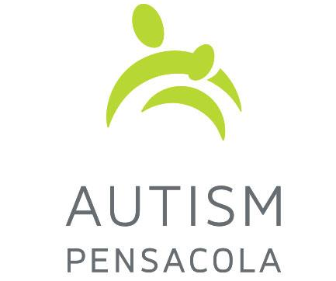
Autism Pensacola, Inc.
2019 Holiday Gift Card Program Application Form
Application deadline is November 5, 2019

Name and age of Child with autism: ____________________________________

Parent/Guardian Name: _____________________________________________________

Total Number of Family Members in Household: ___________________________

Address: ___________________________________________________________

___________________________________________________________

Phone Number: _____________________________________________________

Email: _____________________________________________________________
Application Process:
- This application form must be completed in full and submitted no later than November 5, 2019 to:
Autism Pensacola
10001 N. Davis Highway, Building 1
Pensacola FL 32514
Or
Email: shanan@autismpensacola.org

- Applications must include two letters in order for consideration:
  - a letter explaining financial need
  - a letter of recommendation from a school or other agency

You will be notified by December 5, 2019 if you are a recipient. If you are not selected for one of the cards in this program, you may wish to pursue alternative avenues of support/assistance through other agencies and organizations.

For office use only:
Rcvd:______________ Rvwd______________ Rvwd______________ Status______________

